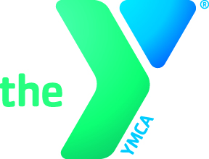
YMCA volunteers
The 5 step Process

Step 1 All interested volunteers must fill out an online application through the YMCA of Delaware website.

Step 2 Prospective volunteers are contacted by the Volunteer Coordinator with a requested to complete the Volunteer Background Check.

Step 3 After the background check returns clear, the Volunteer Coordinator will contact the volunteer applicant and request they complete the Smarter NOW online child abuse prevention training. The volunteer will be required to return a copy of the completed training certificate, and also visit a branch to have their picture taken for their Volunteer Photo ID.

Step 4 Meanwhile, the Volunteer Coordinator will contact the department leader, where the applicant wishes to volunteer, and sends the leader a Reference Check Form. The department leader must thoroughly check two references, and return the completed form to the Volunteer Coordinator.

Step 5 Once all the required paperwork and training is completed, the volunteer applicant will be issued a Volunteer Photo ID. The volunteer can now begin volunteering!

Branch Volunteer Contacts

Volunteer Coordinator: ______________________________

Authorized Users
For Background Checks: Shanna Slavin
Kelly Moore

These standards are set forth by the YMCA of Delaware Association. Any additional questions can be directed to Bev Marvin or Jim Ryan.

