PROCESSING A VOLUNTEER

- There are many steps in processing a volunteer. Here is how it will work:
- You will receive a volunteer’s application via email. Save this document to a folder which you will retrieve later in the instructions. You will enter the volunteer’s name in Protivity. If they come up in Protivity as a current member go to their Family Tab and click on their name to ensure that a journal does not come up identifying them as a Megan’s Law Offender.
- If the volunteer is not in the system enter their name, address, phone number, etc.
- If this is a new applicant and has never volunteered before, you may want to set up an interview with the Program Director before sending the screening link. If this is what you have been doing in the past please continue what you were doing.
- Look into the application to see where their interest is so we can add them to a mailing list. Here are the choices: If they choose more than one you can put them under General.

    - VOLAQUATIC Volunteer - Aquatics
    - VOLCCHILD Volunteer - Child Care
    - VOLGENERAL Volunteer - General
    - VOLSPORTG Volunteer - Sports

- To add a member to a mail list go to add activities and select Mailing List. You can type a “V” in the little white block under Mailing List to bring the list up quicker or just keep paging down under you see the mail code you need. You can make the begin date today and I believe we will check every 3 years so you can make the end date the end of this year or 3 years down the road.
- Next attach the application to the Volunteer’s member record. While you are in the Activity Screen, click on the tab above that reads Documents. There is an Attach key on the left side of the screen under the member’s name. Click on Attach. Use the Category Volunteer Forms; you can use any Description that makes sense to you. The authority allows everyone to see the document which is Public, or it allows only you to view the document. Click on the Browse and find your volunteer’s application then click save.

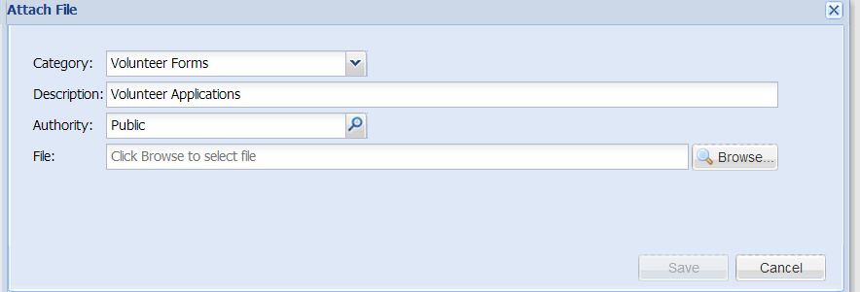

- Next click on the Personal Tab. You can type Volunteer to bring up the form. As you complete each step please put in the date of completion. Enter the date the application was received.
- You will receive 2 email templates. One to send acknowledging the application and give the volunteer a link to complete the background check. The other template to send after the background check has been approved with the link for the volunteer to take the required training online.
- Send the first template acknowledging the application with the link marked Step 2 below. Now go to the Personal Information and mark the date the email for the background check was sent.

Page 2 - Volunteers

- Once the background check has been completed you will be notified by the staff who handles background checks for staff at your branch. If there is a discrepancy in the background report it will be discussed with the Branch Executive and/or HR. If the background check is not accepted you will have to notify the volunteer that they cannot volunteer. You will be receiving a standard form letter which you can mail or email the volunteer.
- If the report was good then you need to send the second email template letting the volunteer know they now must complete the training. The link will be included in this template. Once the training has been completed the volunteer must bring in their certificate of completion.
- Right now we are checking at 2 references that are listed on the application.
- Only when all of this has been completed you will make the volunteer a badge. We are going to also give you a template for the badge and I will send you instructions on making the badge and copying the volunteer picture to the badge once we receive the template. If the volunteer is not a member please take their picture at the front desk.
- Remember to also go into the Personal Information Screen to enter the dates the emails were sent, and the dates the screening and training was completed,
- I will give you a report you can run to check the status of your Volunteers.
- Volunteer shirts must read VOLUNTEER in large letters on the shirt for additional identification.
- Tina Rydgren will give you a list of level 2 volunteer positions and equivalences for the online Redwood training.

Coordinators and Authorized Users for Background Check:

Listed below are the Volunteer Coordinators and the staff who are authorized users for the background checks. Please note that each Coordinator must also have a backup staff. Please let Gabe and me know who that person is so they may also receive a copy of the volunteer application and instructions on how to process volunteers.

Authorized Users for
Volunteer Coordinator Background Check

Bear-Glasgow
Jamie McMahan Patti Vozenilek

Brandywine
Colleen Mulligan Diane Coyle

Central
Deric Clinton Shanna Slavin

Dover
Judi Shade Mary Jo Carey

Sussex
Lauri Weeks Shanna Dazie

Western
Sandy Tilford Karen Jordan

Page 3 – Volunteers

Templates:

Step 2 – Thank you for your Application Email:

Thank you for applying to be a volunteer with the YMCA of Delaware. We are delighted for you to become a part of our organization.

The next step to follow is to complete your background check. The background check is no cost to you and should only take a few moments of your time.

To complete your background check visit https://ymcade.quickleasepro.com/apply/applicant/new/21?_ref=fc9bf7a41f9b8b1e6a9658a068af68f21fce2279e7787860843e1c30181d757c and select the branch where you wish to volunteer.

A YMCA representative will contact you shortly after your background check is complete.

Thanks for your interest in volunteering with the YMCA of Delaware.

Step 3 – Training Link Email:

Dear Volunteer,

Thank you for applying to be a volunteer with the YMCA of Delaware. We are delighted for you to become a part of our organization.

Your background check has been completed. The final step is to complete the online training course provided by Redwoods. This training only takes an hour.

Online Child Sexual Abuse Prevention Training
(required for all Level 2 volunteers)

An 80% score or better on the test, will be required for successful completion.

To complete the training, please follow these instructions:
1. Visit http://firstnetcampus.com/Redwoods/entities/YMCA/logon.htm

2. If you are a New User - Click on “I Am A New User”
(if you already are registered on this website please sign in and proceed to step 6)

3. Select “Delaware” and “YMCA of Delaware”

4. Enter your Access Code (Branch Specific)
Association Office - 011086
Bear Glasgow Branch – 011088
Brandywine Branch – 011089
Camp Tockwogh – 011090
Central Branch – 011093
Dover Family YMCA – 011087
Resource Center – 011083
Sussex Family YMCA – 011082
Walnut Street Branch – 011101
Western Family Branch - 011105
Page 4 – Volunteers

5. Fill out the registration information and create a user name and password -
Make a note your user name and password - If you log out and come back later and can’t remember your log in. Please do not make a new one. Contact the volunteer coordinator for your sign in information.

6. Once you enter the site, click on the box labeled “Youth Programs”

7. On the left side of the screen, find the “Core Courses “ Training listing

8. Complete the following training module:
a. Child Sexual Abuse Prevention (~60 min)
9. Print the certificate of completion

THE CERTIFICATE MUST BE TURNED IN TO THE VOLUNTEER COORDINATOR AT YOUR BRANCH.
Individuals interested in learning more about protecting children from sexual abuse can contact Nicki Mowbray at the YMCA Resource Center, 302-254-YMCA ext. 133, or at nmowbray@ymcade.org and register for the Stewards of Children program. Stewards of Children is the only nationally available program scientifically proven to increase knowledge, improve attitudes and change child-protective behaviors. This revolutionary program is for any responsible adult who cares about the welfare of children.

Upon completion of the training, you will be immediately be issued a certificate. Please print this out and bring to the branch on your next visit.

Creating a Name Badge for your Volunteer:

- Click on the link below for the template. You can save this is your Power Point if you wish to instead of clicking on the link all the time.

https://dl.dropboxusercontent.com/u/3617236/association/volunteer/badge.pptx

- To add Gabe’s picture that you took in Protivity search for Gabe in Protivity by entering his First and Last name in the Search Screen and hit search.
- When his name prompts below double click on his name. Go to the Family Tab listed on the top of the screen.
- Highlight Gabe’s name and click on your Change Icon above his name.

Page 4 - Volunteers

- Go got his name again and click on the Change Icon again.
- Right click on his picture and click on Save Image as….
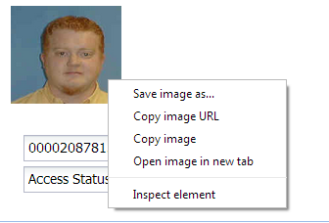

- You must save this picture as a JPEG Image but you can save it under his name. You may want to create a folder called Volunteer Pictures in case you have to create another badge for a Volunteer because they may have lost or destroyed their badge.
- Go to your Power Point Template and click on Insert Tab above the document.
- Below the Insert Tab is an Icon which reads Picture. Click on picture and it allows you to bring up the file you saved with the person’s picture. Click on picture and insert. You can now size the picture to fit the template. It is not necessary to print the name of your branch but you should print the person first name in all caps so it is noticeable. Print the badge on white card stock.
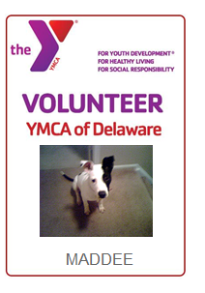

Tina is looking into buying laminated pouches to insert the pictures and also sleeves to fit the badge. We will order lanyards to begin with for all your volunteers.

Use current coaches shirt and/or design from YUSA but you must provide your volunteer with a shirt that reads VOLUNTEER.

