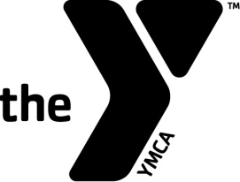

January 22, 2015

Name
Address
City, State Zip

Dear Name,

Thank you for completing the YMCA of Delaware Volunteer Application. At this time, the YMCA of Delaware does not have a volunteer position that matches your qualifications and/or interests. Please contact <branch exec or volunteer coordinator> if you have any questions regarding your application.

Sincerely,

Name
Volunteer Coordinator
Branch

